**Vesak or Visakah Puja**

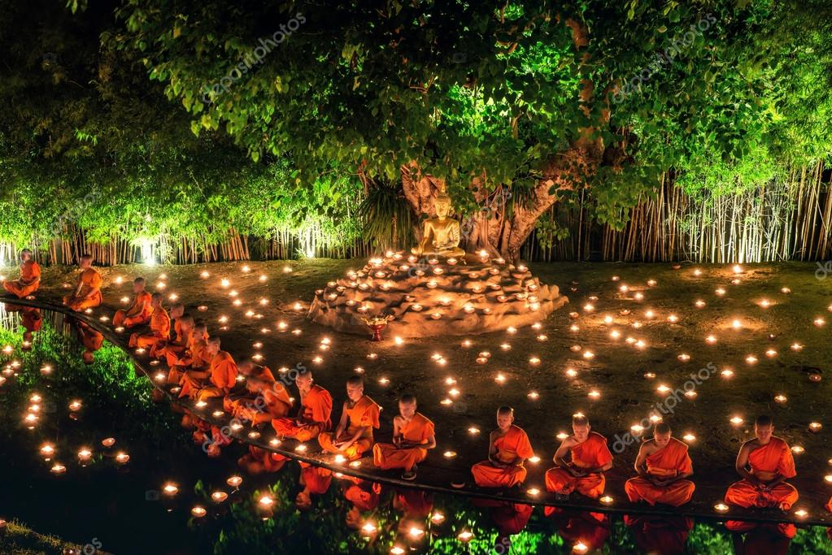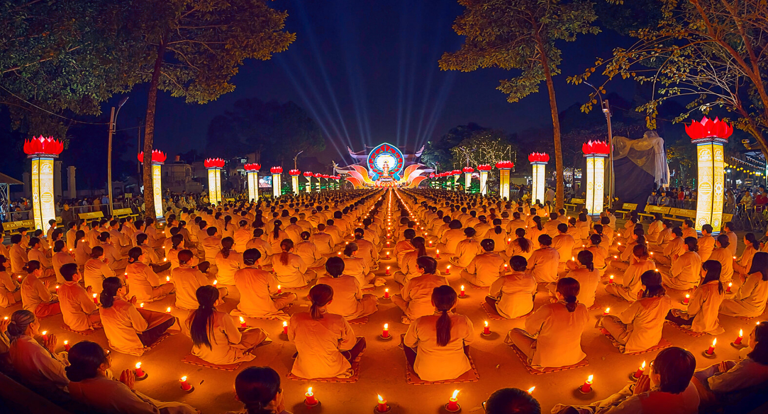'Vesak', the Day of the Full Moon in the month of May, is the most sacred day to millions of Buddhists around the world. It was on the Day of Vesak two and a half millennia ago, in the year 623 B.C., that the Buddha was born.-Magha Puja Day (Fourfold Assembly or 'Sangha Day') …-Magha Puja Day commemorates an important event in the life of the Buddha, in which the four disciples traveled to join the Buddha. Date Details: Full moon day of the 3rd lunar month. General Practices: Buddhist gather at temple at dusk where they make merry, share flowers, incense and lit candles.